SAVEETHA INSTITUTE OF MEDICAL AND TECHNICAL SCIENCES
(SIMATS)

Department of Computer Science and Engineering
CO1 – AT1: CASE STUDY ANALYSIS
Course: Software Engineering

Intelligent AI-Based Airport Baggage Tracking
and Management System
Submitted by
THIYAGESH (192572007)

Understanding the Problem Statement

Problem Overview
Every year, airports around the world handle millions of checked bags, moving them through check-in counters, security screening, sorting belts, aircraft loading bays, and connecting flights before they finally reach a passenger at the destination carousel. This process depends on tight coordination between airline staff, ground handling teams, and airport infrastructure, and even a small breakdown in that coordination — a missed scan, a wrongly sorted bag, or a delayed transfer — can send a suitcase to the wrong city or leave it sitting on a belt long after its owner has left the airport. Traditional baggage handling systems, which typically rely on barcode tags and periodic manual scans, offer very limited insight into where a bag actually is at any given moment. Passengers rarely know why their bag has not arrived, and airline staff often discover a misrouted bag only after a complaint has already been filed.
This case study looks at how an AI-driven baggage tracking and management platform, built around RFID tagging, IoT-enabled sorting infrastructure, and predictive analytics, can close this visibility gap. Instead of treating baggage handling as a series of disconnected manual checkpoints, the proposed system treats it as a continuously monitored process, where every scan event feeds into a live tracking record and a prediction engine that can flag problems before they escalate into lost baggage.

Objectives of the Proposed System
- Track the location and status of every checked bag in real time, from check-in to arrival.
- Optimize the routing of bags through sorting and transfer points to reduce handling time.
- Use AI models to anticipate likely delays or misroutes before they occur, rather than reacting after the fact.
- Automatically notify passengers about the status of their baggage at key milestones.
- Reduce the overall rate of baggage misrouting across connecting flights.
- Provide airport and airline management with operational reports for performance monitoring.
- Support broader airport logistics planning through consolidated tracking data.
- Improve passenger satisfaction by replacing uncertainty with clear, timely information.

Scope of the Problem
The scope of this case study covers the software and data layer of baggage management within a single airport terminal environment, including its interfaces with airline check-in systems, RFID readers positioned along the sorting and transfer path, and a passenger-facing notification channel. It does not extend to redesigning the physical conveyor and sorting hardware itself, nor does it cover inter-airport customs and international regulatory systems in full depth, though the design does account for handing off tracking data at connecting airports where compatible infrastructure exists. The proposed solution is scoped as a platform that airports and airlines can adopt incrementally, starting with RFID tagging at check-in and expanding to predictive analytics as historical data accumulates.

Identifying Key Stakeholders and Challenges
A baggage handling platform touches a wide range of people, from the passenger dropping off a suitcase to the engineers who keep the tracking servers running. Understanding what each group needs from the system — and where the current process lets them down — is necessary before any software solution can be designed sensibly. Table 1 summarizes the main stakeholders identified for this case study.
Stakeholder | Role / Responsibility | Key Challenges Faced
Passengers | End users who check in baggage and expect timely, damage-free delivery. | Lack of visibility into bag location; anxiety over lost or delayed bags; limited communication from airline.
Airline Ground Staff | Tag, load, and reconcile baggage at check-in counters and aircraft bays. | Manual scanning errors; time pressure during quick turnarounds; incomplete handover records between shifts.
Airport Baggage Handling Operators | Operate sorting belts, conveyors, and transfer systems within the terminal. | Equipment breakdowns; difficulty pinpointing where a bag is stuck in the sorting chain.
IT / Systems Maintenance  Team | Maintain the tracking software, servers, and network infrastructure. | Integrating new sensors with legacy airline reservation systems; ensuring uptime during peak travel.
Airport Authority /  Management | Oversee overall terminal operations and service-level performance. | Balancing infrastructure investment cost against measurable gains in efficiency and complaint reduction.
Regulatory and Security Bodies | Enforce customs, safety, and datahandling regulations. | Ensuring the tracking platform does not compromise security screening or passenger data privacy.
Technology Vendors  (RFID/IoT/Cloud) | Supply and maintain hardware, sensors, and cloud infrastructure. | Meeting airport-specific reliability standards; supporting integration across multiple airline systems.
Table 1: Stakeholders, Roles, and Associated Challenges
Two patterns stand out across these stakeholder groups. First, almost every challenge traces back to a lack of shared, real-time visibility — ground staff, operations teams, and passengers are all effectively working with partial or delayed information about the same physical object. Second, the stakeholders with the least ability to influence the process directly, namely passengers, are often the ones most affected by its failures. Any proposed solution needs to address both of these patterns: it must give operational staff a unified live view of baggage movement, and it must extend a version of that visibility to passengers themselves.

Analyzing the Current Approach

Existing Process
Most airports currently rely on a barcode-based baggage handling system, sometimes referred to as BHS (Baggage Handling System), where a printed tag is attached to each bag at check-in and scanned at a limited number of fixed checkpoints along the sorting line. These scans are logged individually rather than streamed continuously, which means the system knows a bag was at a particular scanner at a particular time, but has no visibility into its position between checkpoints. Reconciliation between an airline's departure control system and the airport's physical sorting infrastructure is often handled through periodic batch updates rather than a live data feed.

Strengths of the Existing System
- Barcode tagging is inexpensive and already standardized across most airlines worldwide.
- Fixed scanner checkpoints are a mature, well-understood technology with predictable maintenance needs.
- Staff are already trained on existing scanning procedures, keeping day-to-day operational overhead low.

Limitations and Gaps
- Barcode tags can be smudged, torn, or misaligned, causing scan failures that break the tracking chain.
- Line-of-sight scanning at fixed points leaves long stretches of the journey completely unmonitored.
- The system is purely reactive — a misrouted or delayed bag is typically identified only after a passenger complaint or a missed connection, not beforehand.
- There is little to no predictive capability, so recurring delay patterns at busy transfer points are not flagged until they have already caused a backlog.
- Passenger communication is minimal or absent, leaving travelers without any way to check on their bag's status.
Taken together, these gaps show that the fundamental limitation of the current approach is not the absence of technology, but the absence of continuity and foresight in how that technology is used. The proposed solution, described in the next section, is built specifically to close these two gaps.

Proposed Software Solution

Solution Overview
The proposed platform replaces isolated barcode checkpoints with a continuously connected tracking layer built on RFID tags, IoT-enabled sorting sensors, and a cloud-based analytics backend. Each bag is tagged with a passive RFID chip at check-in, and RFID readers placed at every major transfer point — sorting belts, loading bays, and transfer buses — capture its movement automatically, without requiring a direct line-of-sight scan. This continuous stream of location events is fed into an AI-based prediction engine that learns from historical transfer patterns to flag bags at risk of delay or misrouting while there is still time to intervene.
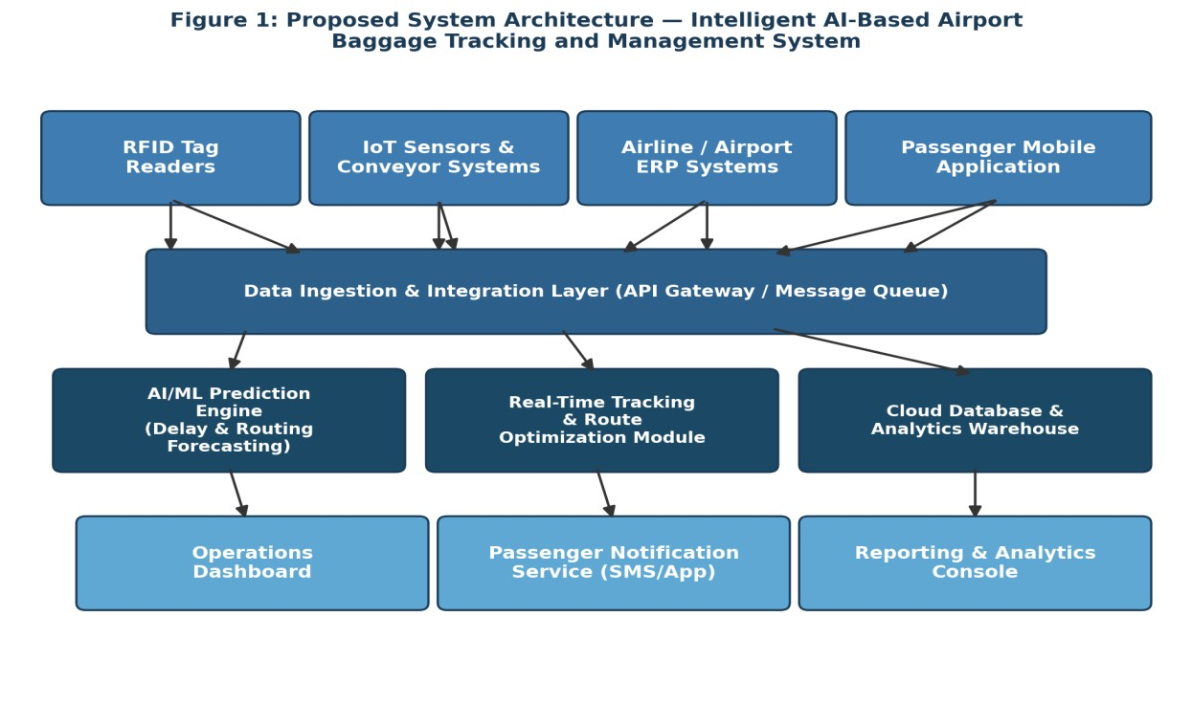
Figure 1: Proposed System Architecture
As shown in Figure 1, the architecture is organized into four layers: a data-capture layer of RFID readers, IoT sensors, and existing airline systems; an ingestion layer that normalizes and queues incoming events; a processing layer containing the AI prediction engine, the route optimization module, and the analytics warehouse; and a presentation layer consisting of the operations dashboard, the passenger notification service, and the reporting console. Figure 2 illustrates how a single bag moves through this system end to end, from check-in to final arrival notification.
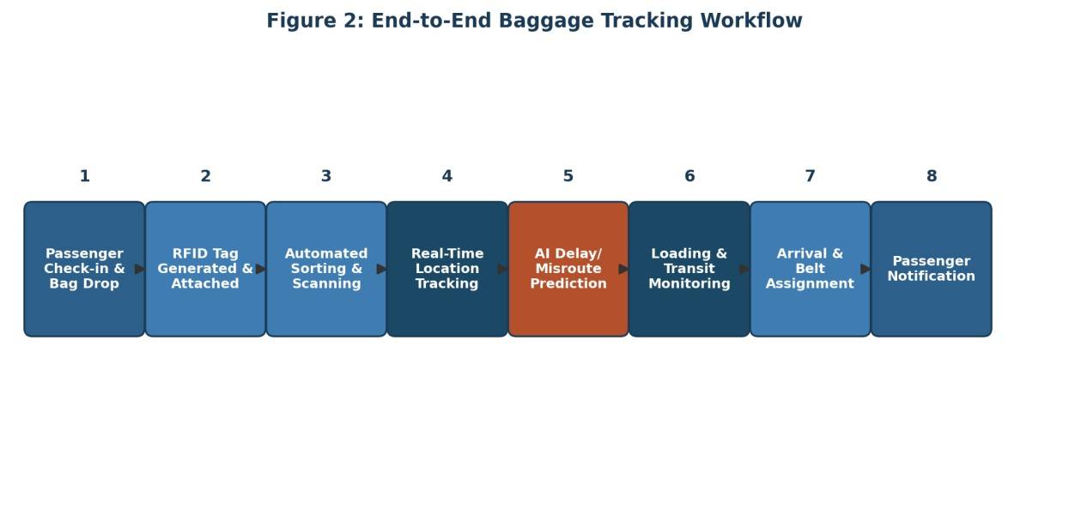
Figure 2: End-to-End Baggage Tracking Workflow

Major Functional Modules
- RFID Tagging and Check-in Module — generates and links a unique RFID identifier to each bag at the point of check-in.
- Real-Time Tracking Module — aggregates RFID and IoT scan events into a live location record for every bag.
- AI Prediction Engine — analyzes historical and live transfer data to forecast the likelihood of delay or misrouting.
- Route Optimization Module — recommends sorting and transfer paths that reduce handling time, especially for tight connections.
- Passenger Notification Service — sends automated status updates through SMS and a companion mobile application.
- Operations Dashboard — gives ground staff and supervisors a live operational view of baggage flow across the terminal.
- Reporting and Analytics Console — produces periodic reports on handling time, delay rate, and misroute patterns for management review.

Functional Requirements
ID | Functional Requirement | Description
FR-1 | Real-time baggage tracking | System shall capture and display the current location of each tagged bag as it moves through the airport.
FR-2 | Automated RFID tag generation | System shall generate and associate a unique RFID identifier with each bag at check-in.
ID | Functional Requirement | Description
FR-3 | Delay/misroute prediction | AI module shall flag bags at risk of delay or misrouting based on historical and live transfer data.
FR-4 | Passenger notification | System shall send automated status updates to passengers via SMS or a mobile application.
FR-5 | Route optimization | System shall recommend optimal sorting and transfer paths to reduce transit time.
FR-6 | Operational reporting | System shall generate analytics reports on handling time, misroute rate, and delay patterns.
FR-7 | Role-based dashboard access | System shall provide differentiated dashboard views for ground staff, operations managers, and administrators.
Table 2: Functional Requirements Summary

Non-Functional Requirements
Quality Attribute | How it is Addressed
Scalability | Cloud-hosted microservices that scale horizontally during peak travel seasons and holiday rushes.
Reliability | Redundant tag readers and failover database replicas keep tracking active even if one node fails.
Maintainability | Loosely coupled modules with documented APIs allow individual components to be updated without disrupting the whole platform.
Usability | Simplified dashboards for ground staff and a lightweight passenger-facing notification interface.
Security | Encrypted data transmission, role-based access control, and compliance with aviation data-protection norms.
Performance | Tag scan events are processed and reflected on dashboards within a few seconds of capture.
Table 3: Non-Functional Requirements Summary

Application of Software Engineering Principles
The system is deliberately organized as a set of loosely coupled microservices rather than a single monolithic application, so that the RFID ingestion service, the prediction engine, and the notification service can each be developed, deployed, and scaled independently. This modularity keeps individual components small enough to test and reason about on their own, and it means a failure or slowdown in one module, such as the notification service during a spike in SMS traffic, does not bring down the core tracking functionality.
Scalability is handled by hosting the platform on cloud infrastructure that can add processing capacity automatically during high-traffic periods such as holiday travel seasons, rather than being sized for a fixed peak load. Reliability is addressed through redundant RFID readers at critical checkpoints and database replication, so that a single hardware fault does not create a blind spot in tracking coverage. Maintainability is supported by documenting every module's API contract clearly and keeping business logic, such as the delay-prediction rules, separate from the data-ingestion code, which allows the AI model to be retrained and redeployed without touching the rest of the system. Usability is addressed by designing separate, purpose-built interfaces for ground staff and for passengers, since the two groups need very different levels of detail. Finally, security is built in through encrypted data transmission between readers and the cloud backend, and role-based access control that limits which staff members can view or modify tracking records.

Justifying the Chosen Methodology
An Agile development approach, specifically the Scrum framework, is recommended for building this platform, with short two- to three-week sprints delivering incremental, testable pieces of functionality. Figure 3 shows the sprint cycle that the development team would follow, moving from backlog planning through design, development, testing, review, and retrospective before beginning the next iteration.
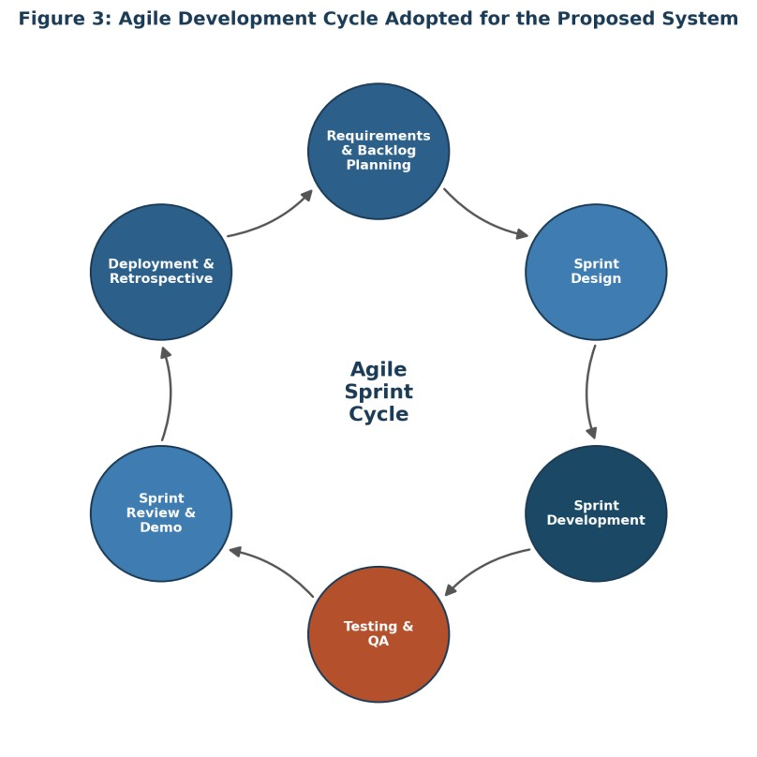
Figure 3: Agile Development Cycle Adopted for the Proposed System
Agile is a better fit for this project than a strictly sequential model such as Waterfall for a few practical reasons. The core tracking and notification modules can be built and validated in an early sprint using existing barcode-equivalent data, while the AI prediction engine — which depends on accumulating real transfer data before it can be trained meaningfully — can be developed and refined in later sprints without blocking the rest of the platform. Airport operations staff can also review working increments of the dashboard early and often, which matters because their day-to-day workflow knowledge is difficult to capture completely in an upfront requirements document. Regular sprint reviews give them a chance to catch usability issues before the system is fully built rather than after.
Because the platform also needs frequent, low-risk updates once it is live — for example, retraining the prediction model as new delay patterns emerge, or adjusting notification templates — the Agile process is paired with DevOps practices such as continuous integration and automated deployment pipelines. This combination allows the development team to ship small, well-tested changes frequently rather than bundling updates into large, risky releases, which keeps the system stable while still letting it evolve with airport operations.

Expected Outcomes and Limitations

Expected Outcomes
- Reduced baggage loss, since continuous RFID tracking closes the blind spots left by fixed barcode checkpoints.
- Faster baggage delivery, driven by route optimization at sorting and transfer points.
- Improved airport operations, as ground staff gain a live, consolidated view of baggage flow instead of fragmented checkpoint logs.
- Better passenger experience, through proactive status notifications rather than silence until arrival.
- Increased baggage tracking accuracy across the full journey, not just at scan checkpoints.
- Lower operational costs over time, as fewer bags require manual tracing and reconciliation.
- Enhanced logistics efficiency, supported by analytics that reveal recurring bottlenecks.
- Improved airline service quality and fewer compensation claims tied to lost or delayed baggage.

Risks, Implementation Challenges, and Limitations
Several practical challenges would need to be managed during rollout. RFID tags and readers involve a higher upfront hardware cost than barcode printing, which may slow adoption at smaller or budgetconstrained airports. The platform's real-time capabilities depend on stable network connectivity throughout the terminal, and any coverage gaps, particularly in older buildings or underground transfer tunnels, could reintroduce blind spots. Integrating the new tracking layer with legacy airline departure control systems is likely to be one of the more time-consuming parts of implementation, since these systems vary significantly between carriers and were not originally designed for continuous data feeds.
The accuracy of the AI prediction engine is also directly tied to the quality and volume of historical data available; during the initial months of deployment, before sufficient transfer history has accumulated, delay predictions would be less reliable than they would become later. Staff would need training on the new dashboard and escalation workflows, and passenger data collected for notifications must be handled in line with data protection regulations, which adds compliance overhead. None of these challenges are unusual for a system of this scope, but they do mean that a phased rollout, starting with core tracking before layering in predictive features, is a more realistic path than a single full-scale launch.

Future Enhancements
- Extending predictive tracking across airline partner networks for smoother international transfers.
- Adding computer-vision-based bag condition checks to detect damage before it becomes a liability dispute.
- Introducing a self-service passenger portal for rebooking delayed baggage delivery to a preferred address.

Conclusion
Baggage delays and misrouting are, at their core, a visibility problem: airlines and airports lose track of where a bag actually is between the handful of checkpoints a barcode system can see. By replacing that patchwork of checkpoints with continuous RFID and IoT tracking, and layering an AI prediction engine on top of it, the proposed system turns baggage handling from a reactive, complaint-driven process into one that can flag and correct problems while a bag is still in motion. Delivered through an Agile development process with early, frequent feedback from ground operations staff, this platform offers a realistic path toward measurably fewer lost bags, faster delivery, and a noticeably better experience for passengers.

References
- Sommerville, I. Software Engineering. Pearson Education.
- International Air Transport Association (IATA). Baggage Report — industry statistics on mishandled baggage rates and causes.
- Course material and lecture notes, Software Engineering, SIMATS.

